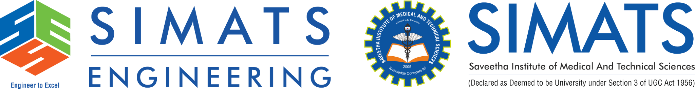
ASSIGNMENT-5
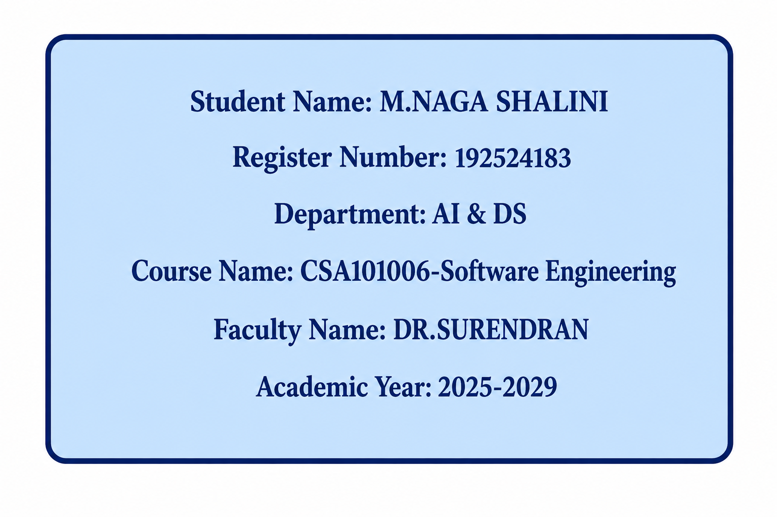
1. Explain Technical Debt. What are the Major Causes of Technical Debt, and How Can Organizations Minimize It During Software Evolution?
Introduction
Technical debt is a common concept in software engineering. It occurs when developers choose a quick, easy, or temporary solution instead of implementing the best long-term solution. Although this may help complete a project faster, it creates additional work and maintenance effort in the future
Major Causes of Technical Debt
- Tight deadlines
Developers may use shortcuts to complete software within a limited time.
- Poor design decisions
Incorrect architecture or design choices can create problems during future development.
- Lack of documentation
Poor documentation makes the system difficult to understand and maintain.
- Inadequate testing
If testing is skipped, bugs may remain in the system and become expensive to fix later.
- Frequent requirement changes
Continuous changes in requirements can make existing code complicated.
- Outdated technologies
Old libraries, frameworks, and tools can increase maintenance difficulties.
How Organizations Can Minimize Technical Debt
- Use good software architecture from the beginning.
- Perform regular code reviews to identify poor-quality code.
- Write automated tests to detect errors early.
- Refactor code regularly to improve its structure and quality.
- Maintain proper documentation of the system.
- Use continuous integration and continuous delivery (CI/CD) to detect problems early.
- Track technical debt as part of project management.
- Update outdated dependencies and technologies regularly.

Conclusion
Technical debt cannot always be avoided, but it can be controlled through good design, testing, documentation, code reviews, and regular refactoring. This helps organizations maintain software quality during software evolution.
Q2. Explain how AI/ML and Edge Computing are transforming modern software engineering. Provide one practical example for each.
Artificial Intelligence (AI) and Machine Learning (ML) are changing software engineering by helping developers automate tasks, analyze data, detect errors, and improve software development processes.
Major Uses of AI/ML
Code generation: AI can assist developers in writing code.
Bug detection: ML techniques can identify possible defects in software.
Automated testing: AI can generate and optimize test cases.
Predictive maintenance: ML can predict possible software or system failures.
Requirement analysis: AI can analyze requirements and identify patterns.
Security: AI can detect unusual activities and possible security threats.
Practical Example of AI/ML
AI-based bug detection:
An organization can use an ML system to analyze previous software defects and identify sections of new code that are likely to contain bugs. Developers can then test those sections more carefully.

2. Edge Computing in Software Engineering
Edge computing processes data closer to the device or location where the data is generated, instead of sending all data to a centralized cloud server.
How Edge Computing Helps
Reduces latency: Data can be processed quickly.
Reduces bandwidth usage: Less data needs to be sent to the cloud.
Improves response time: Applications can respond almost immediately.
Improves reliability: Some processing can continue even when cloud connectivity is limited.
Supports real-time applications: Useful for IoT, autonomous systems, and industrial systems.
Practical Example of Edge Computing
Smart traffic monitoring:
Cameras installed at roads can process vehicle information locally using edge computing. They can detect traffic congestion or accidents immediately and send only important information to the central server.
Conclusion
AI/ML makes software development more automated, intelligent, and predictive, while Edge Computing makes applications faster, more responsive, and efficient. Together, they are important technologies in modern software engineering.

Q3. Case Study – A company deploys dozens of microservices in the cloud and notices that resource usage and energy consumption are increasing. Explain three sustainable DevOps practices that can reduce energy consumption and cloud cost.
1. Right-Sizing Cloud Resources
Organizations should allocate only the CPU, memory, and storage required by each microservice. Unused or oversized virtual machines should be reduced or removed.
Benefit: Reduces unnecessary resource usage and cloud cost.
2. Auto-Scaling
Auto-scaling automatically increases resources when demand is high and decreases them when demand is low.
Benefit: Prevents resources from running unnecessarily and reduces energy consumption.
3. Container Optimization
Containers should be made small and efficient by removing unnecessary packages and services. Unused containers should also be stopped.
Benefit: Requires fewer computing resources, reducing both energy consumption and cloud costs.
Conclusion
Sustainable DevOps practices such as right-sizing, auto-scaling, and container optimization help the company reduce cloud resource usage, energy consumption, and operational costs.

